Welcome Club

**Zoom Link:**

[https://worldrelief.zoom.us/j/82546110098](https://www.google.com/url?q=https%3A%2F%2Fworldrelief.zoom.us%2Fj%2F82546110098&sa=D&ust=1602636032350000&usg=AOvVaw35abzwdMm4OW2K_NmdZq5x" \t "_blank)

Meeting ID: 825 4611 0098

November 20th ~ 3:30pm-4:30pm

Character lesson of the month:

CARING/EMPATHY

Recognizing your feelings

* Understanding how other people feel

**3:30-3:35**

Introduction to Welcome Club - Becca

-Build friendships

-Help each other

-Discuss problems and issues with coaches and students

-Have fun!

-**Transition**- (Becca) “Ok coaches let’s go around and say your name and favorite emoji. Please stay muted so we can hear each the coaches.”

**3:35-3:40**

Introduction of Coaches- We will take turns sharing our name and favorite emoji.

-**Transition**- (Becca) “Now let’s start by playing a game! Get out the 4 emoji pictures from your bag. We will be in our breakout rooms for the game. Make sure you listen to your coaches and you are ready to play!”

**3:40-4:00**

ICEBREAKERS

- Coaches, start your group time by having each student introduce themselves. Next, you will need to explain the definitions of the four emotions and the rules of the game. Be very animated while giving the definitions. Coaches are encouraged to participate.

Definitions:

* + **Anger:** a feeling of dislike, being upset or annoyed.
    - Mad, rage, irritated
  + **Happiness**: feeling pleasure, enjoyment.
    - Cheerful or joy
  + **Sadness:** feeling grief, anxiety and unhappiness.
    - Sorrow or misery
  + **Embarrassed:** feeling confused or foolish in front of other people.
    - Awkward, self-conscious or uneasy.

Rules:

* Each student will have four emoji pictures (happy face, made face, sad face and embarrassed face).
* Coaches will read off different scenarios and the students will show what emotion they identify with by holding up the emoji face that corresponds with that emotion.
* They can also hold up two emoji faces at a time to represent mixed emotions (sad and angry at the same time).
* Have students return to starting position before reading next scenario.

Example: “You are playing soccer with your friends and you are about to score a goal, but you miss the ball and fall down. How do you feel?” The kids will then hold up the emoji pictures they identify with.

Scenarios:

1. Your mom tells you to clean up your toys and clothes. How do you feel?
2. Your teacher calls on you in the Zoom meeting to answer a math question. How do you feel?
3. A classmate makes fun of your English ability. How do you feel?
4. Your dad gets you new clothes for your birthday. How do you feel?
5. Your mom gets her driving permit. How do you feel?
6. Your favorite soccer team is in the championship game but they lose by one goal. How do you feel?
7. Your sister falls off the swings at the park and hurts her arm. How do you feel?
8. Your internet at home stops working and you cannot get your school work done. How do you feel?

Once finished transition directly to empathy/caring: recognizing your own feelings lesson.

**-Transition-** (coaches) “Now let’s move into our discussion groups and talk about the game we played.”

**4:00-4:10**

Lesson: Empathy/Caring: recognizing your own feelings

Discussion questions:

* Did you all notice that not everyone chose the same emotions in the game?

Because we are all different, we can all have similar things happen to us or around us but we might **feel differently** about it.

This is important to remember. Each of us at some time in our lives will feel happy or sad or embarrassed or angry. We might not feel it at the same time but we all have those emotions.

* You can have empathy for those around you when they have those feelings because you’ve had those feelings too.
* What does empathy mean? **Empathy**: understanding how other people are feeling.

If we can recognize our own feelings that can help us recognize feelings in other people and understand how they are feeling. (At this point you could talk about how some people in your group chose a certain emotion during the game or an emotion you would feel if one of the game scenarios happened to you).

* Can anyone share a time when they were very happy? Can anyone share a time when someone in their family was very happy and then everyone in your family was happy for them?
* It makes me feel really happy when you all are having fun at Welcome Club.

**-Transition-** (coach) “Now we have an activity to help us remember to have empathy for others and recognize our feelings. Get the ribbons out of you bags.”

**4:10-4:30 Craft**

**Feelings Bracelet:**

[https://www.makeandtakes.com/fabric-friendship-bracelets](https://www.makeandtakes.com/fabric-friendship-bracelets" \t "_blank)

* Using three different colored strips of fabric, students will braid the strips into a cord. The three strips will represent different emotions.

Coaches: “Sometimes we don’t just feel sad, sometimes we can feel sad and angry at the same time. Or sometimes we are embarrassed and happy at the same time. These bracelets help us remember that we ALL have emotions and feelings. It also helps us remember that sometimes are emotions and feelings can mix together. Let this bracelet help you remember to have empathy for those around you. Try to understand how other people are feeling because you have those feelings too. You just might feel it at a different time.”

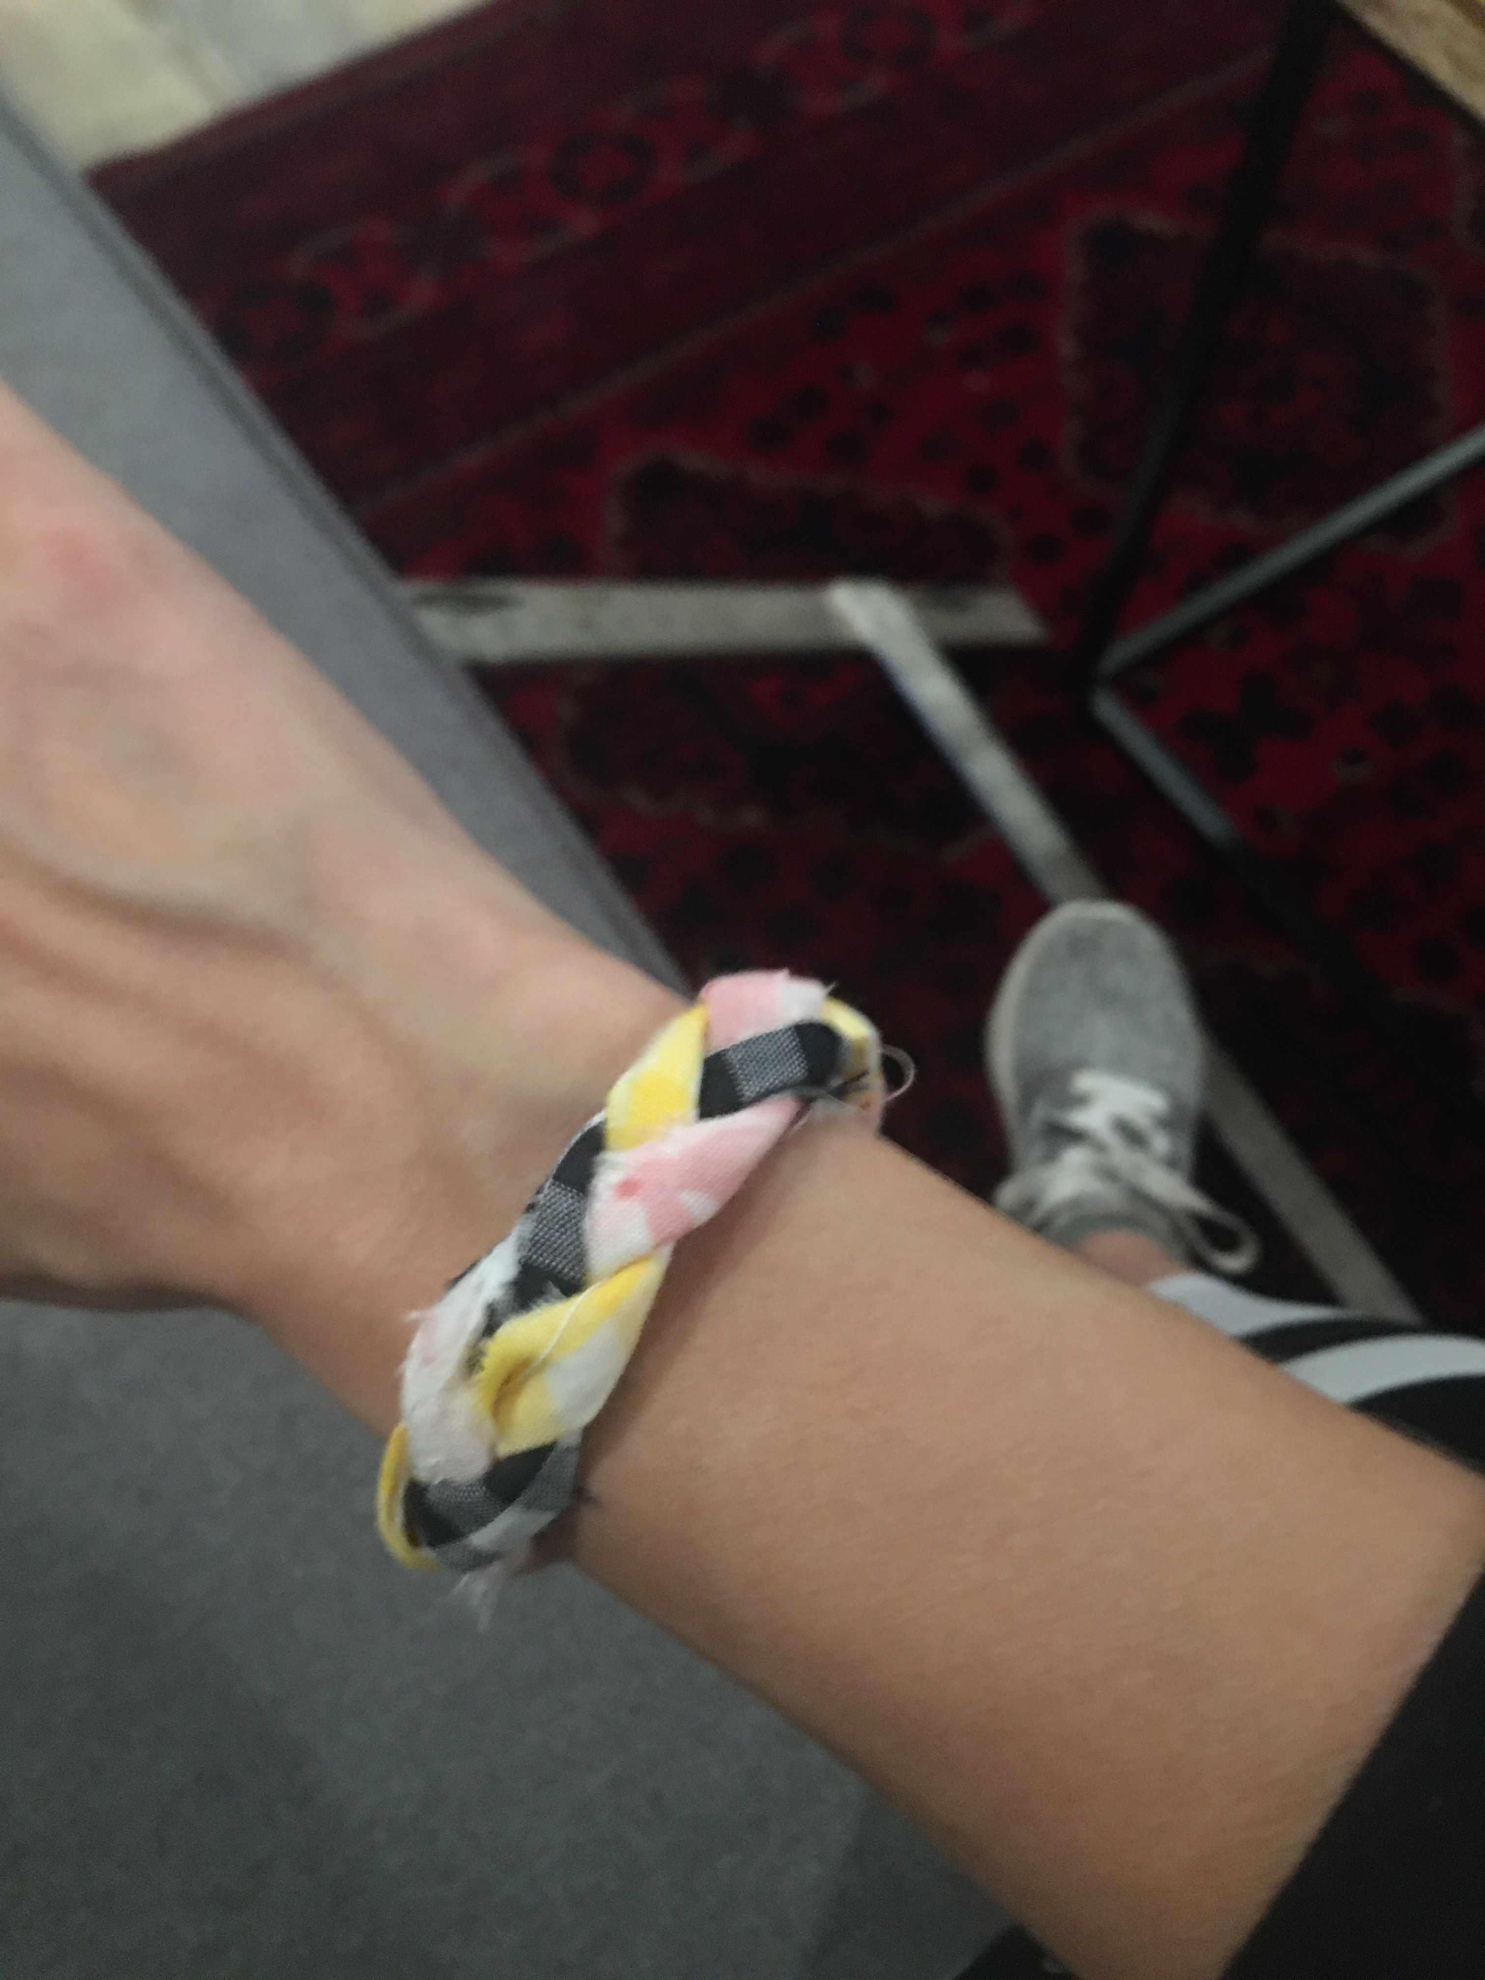 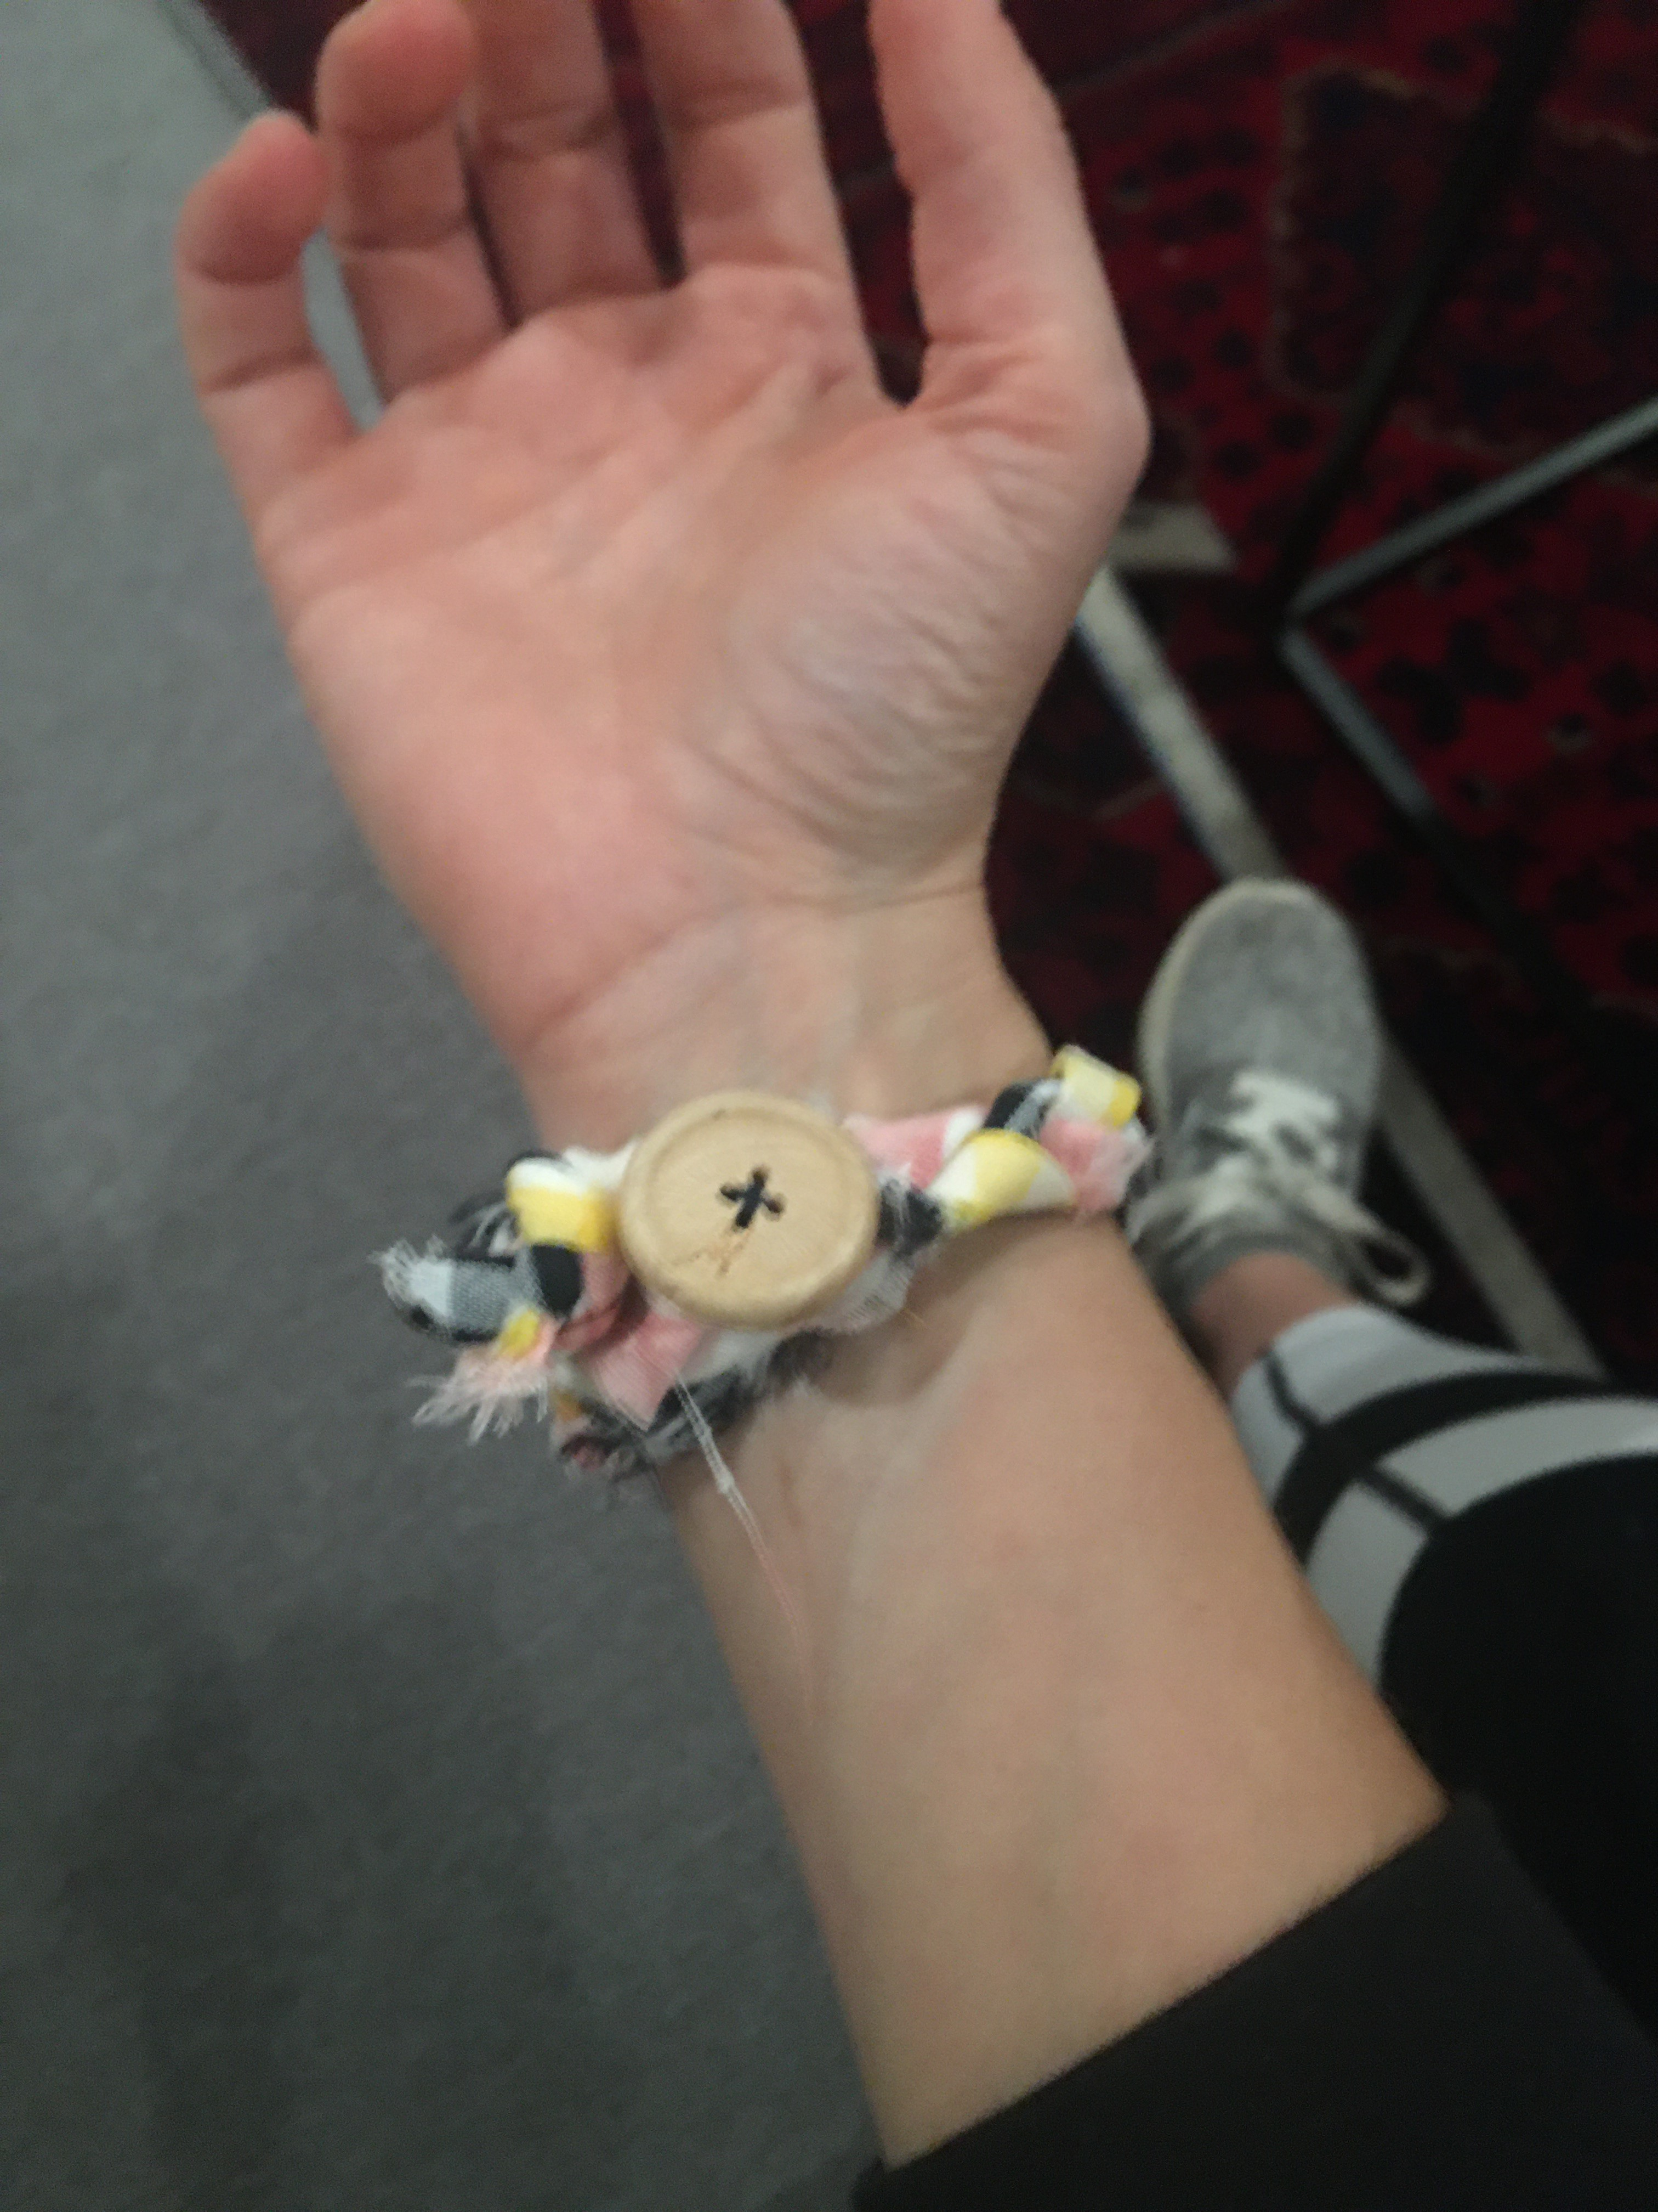

**-Transition-** (coach) “Ok everyone! You all have done an awesome job with your bracelets today! I hope when you wear them you remember to have empathy for others.”

**4:30**

Wrap up and Goodbyes

* Updates and information- Makayla
* Tutoring- Thursday 2:30pm